

Exploring

the Way

with

Our Neighbours





Glory be to the Father –

in whom we live and move

and have our being.

Glory be to the Son –

whose name we bear

and who calls each of us

to be his disciples;

to build his Kingdom

and to go out into the world

and bear its fruit.

Glory be to the Holy Spirit –

pouring out grace and guidance,

forming us and renewing us.

Inspire us all

in the Diocese of Hexham and Newcastle

to live the Gospel,

to be open to change

and to move forward together in hope.

**Foreword from Bishop Séamus**

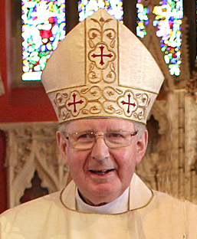It is clear to me that the Holy Spirit is moving throughout our diocese. There was a great deal of work done by communities completing the very substantial questionnaire last year. There have been many lay people and clergy helping to review over 7,000 documents, surveys from young people, individuals and parishes, as well as a small team looking at the comments of priests and deacons.

We hope that the same Spirit will be with us now as we enter the next phase of our consultation.

Pope Francis tells us: *‘The parish is not an outdated institution precisely because it possesses great flexibility; it can assume quite different contours depending on the openness and missionary creativity of the pastor and the community.’*

*(Evangelii Gaudium, Para 23)*

Now is the time when we need to fully explore flexibility, openness and missionary creativity in our diocese.

Over the coming months you will have the opportunity to consider how you can work in partnership with your neighbours and how clergy and lay people can work more closely together to ensure that our communities can flourish in the future.

I urge you to continue praying so that we can all look ahead with faith and courage.



+ Séamus Cunningham

Bishop of Hexham and Newcastle

**Forward Together in Hope - Stages of the Journey**

**PREPARING THE WAY**

* Developing liturgies and prayer resources
* Developing and distributing information leaflets and guidance
* Informing everyone about the approach through meetings, documents and a DVD
* Initial meetings and training for clergy and laity
* Bishop Séamus leads days of reflection

**Autumn 2014 - Spring 2015**



**EXPLORING THE WAY**

* Prayer and liturgies across the Diocese
* Providing unique data to each parish
* Extensive consultation and completion of

Parish Questionnaire in each worshipping community

* Surveys of individuals, clergy and young people
* Detailed analysis and review of all responses and feedback to parishes
* Discussions with neighbours to develop plans for extended partnerships



**Spring 2015 - Autumn 2016**

**POINTING THE WAY**

* Prayer and liturgies across the Diocese
* Initial proposals for a Diocesan-wide Partnership Plan made available to Bishop Séamus to take decisions about the future
* Communicating these decisions and indicating the way forward for everyone
* Supporting parishes in moving to the new arrangements

**Autumn 2016 - Summer 2017**

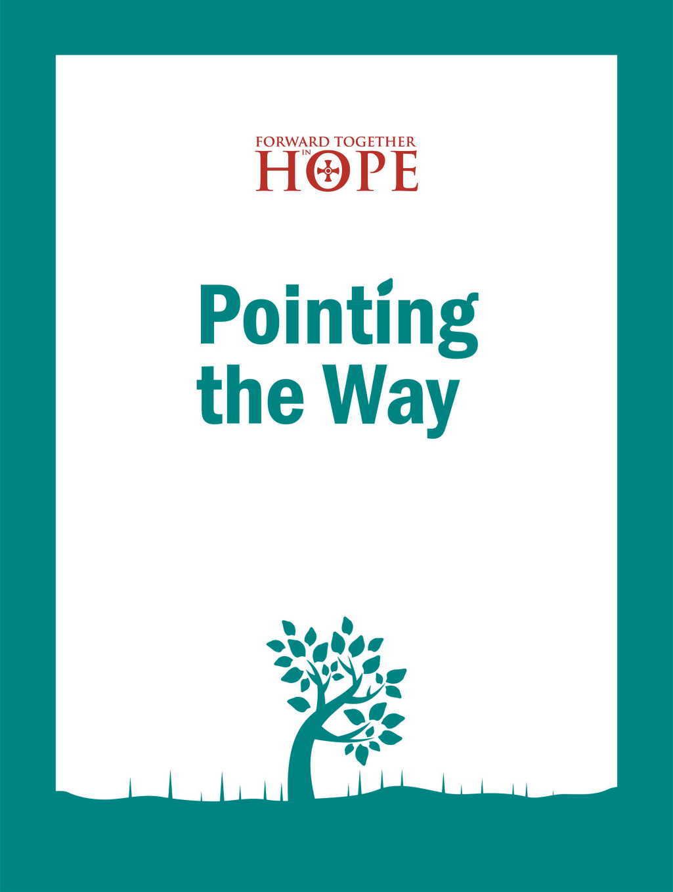

1 Background

*This section explains the overall aim of Forward Together in Hope and how the next stage fits within the journey.*

**1.1 Forward Together in Hope**

*Forward Together in Hope* is our diocesan journey of renewal. It is about all of us, young or old; lay or ordained; in parishes, schools or housebound working together to explore and discern God’s will for our diocese.

As we work through the process it is likely that there will be significant change for all of us. Some communities may not be able to worship in their current church but will be able to thrive by joining with a neighbouring community. Other communities may discover a real sense of responsibility in relation to neighbouring communities. The entire process is firmly rooted in prayer and a real openness to the guidance of the Holy Spirit. The success of *Forward Together in Hope* depends on all of us playing our part and thinking beyond the limits of our experience and imagining new ways to flourish.

**1.2 Stages of the Journey**

We have described the *Forward Together in Hope* process as three stages on a journey - *Preparing the Way, Exploring the Way* and *Pointing the Way* - and the overall ‘map’ and timescales for the journey are shown in the diagram opposite. Of course, a journey like this can never really end, but we hope that after the three years we will have discovered some key indicators regarding the future of the diocese and have started to put the new arrangements in place. Resources will be provided during each stage of the journey to help worshipping communities to reflect prayerfully on the future challenges and opportunities.

Please get in touch if you have any questions, comments or suggestions.

hope@diocesehn.org.uk

www.hope.rcdhn.org.uk

(0191) 243 3304

**1.3 Exploring the Way with Our Neighbours**

****The aim of this document and the accompanying resources is to help communities think and consult further about their current vitality and future direction - initially within parishes and then with their neighbours.

To assist with this we have provided the following items:

* *This document* – a ‘road-map’ giving an overview of the resources and the process of *Exploring the Way with Our Neighbours*.
* *Observations on Your Parish Questionnaire* - drawn up following a thorough review process.
* *A Profile of Your Parish in Numbers* **-** setting out some numerical information and allowing you to see your parish in relation to your deanery and our diocese.
* *From Parish to Partnership –* a document to support parishes in moving towards area partnership arrangements.
* *Summaries of recent surveys of individuals, young people and clergy in the diocese -* to inform and challenge our thinking.
* *Some Food for Thought* – a compilation of practical ideas mentioned by communities in their parish questionnaires.
* *Imagine new ways…* – a short leafletsetting out what is happening over the months ahead and inviting everyone to get involved*.* These have been provided in sufficient quantities for distribution to all parishioners.
* A disc containing the above items electronically. Most of these are also available from the website shown below.

**1.4 Travelling Together on the Way**

We are committed to communicating as well as we can throughout *Forward Together in Hope*. We want as many people as possible to feel part of this journey and would encourage you to spread this information as widely as you can.

2 Exploring the Way with Our Neighbours

*This section provides an insight into the next stage our journey and describes the process and the range of resources available.*

**2.1 A quick recap**

It is exactly a year ago since every worshipping community in the diocese began to look at a detailed Parish Questionnaire with its ten main headings. This gave each community the opportunity to look carefully at themselves. You may remember that *Part A* looked at facts and figures and *Part B* invited everyone to discuss reflective questions which began to explore how the community might look in the future. There is no doubt that we are living in a time of decline in the number of clergy and parishioners, but that is no reason to feel that we cannot belong to a viable and flourishing community.

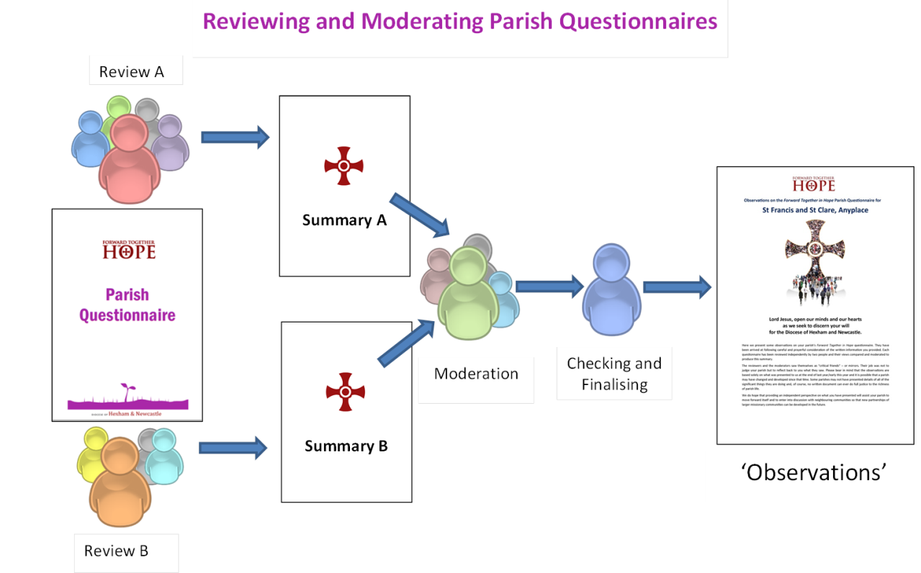

**2.2 Observations on Parish Questionnaires**

We are very aware of how hard most parish communities worked on consulting about and then completing their Parish Questionnaire so it was vitally important that the process for reviewing these was as thorough and as consistent as we could make it.

Every questionnaire was carefully considered by two people from a team of independent reviewers. Once their reviews were returned to us, another team of volunteers took these and combined the two perspectives into a single ‘moderated’ response. This moderated document was then looked over by one of the *Forward Together in Hope* team, and the final version is what has been made available to your community as the **‘Observations’** document.

In this way we have been able to prepare a unique response for every parish in the diocese and we offer it to you for your further discussion and reflection.

We all owe a great debt of thanks to everyone who worked so hard and burned so much ‘midnight oil’ in helping to prepare these documents.

The reviewers and the moderators saw themselves as ‘critical friends’ – or mirrors. Their job was not to judge your parish but to reflect back to you what they saw. Please bear in mind that the observations are based solely on what was presented to us at the end of last year/early this year and it is possible that a parish may have changed and developed since that time. No written document can ever do full justice to the richness of parish life but we offer it as an honest attempt to provide an impartial perspective to help your further thinking.

We hope that it will give every parish the opportunity to look at itself once again and begin to look to the future. Please do all that you can to ensure that the *Observations* are made widely available to as many people as possible. It may help to look again at your Parish Questionnaire response in conjunction with these *Observations*to see how they actually fit together.

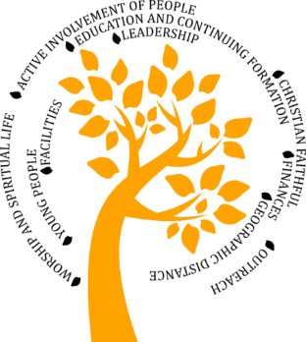The *Observations*cover the 10 main headings presented in the Parish Questionnaire, and look at how each community engaged with the questions asked. There are also comments at the beginning about what your parish appears to do well, followed by observations about how the community seemed to engage with the whole consultation process.

In addition, we have included a page which we have entitled ***A Profile of Your Parish in Numbers*.** This focuses on areas such as age profile, income and Mass attendance with graphs and charts. There is some comparative information included which may help you to see where you are in relation to others in the diocese.

It may help with future discussions in your community if you could ask yourselves the following questions.

In the light of the *Observations:*

* What do we need to do to become a community that witnesses to Jesus in our world today?
* What areas of parish life can be developed with the help of trained lay people?
* With which local communities can we see ourselves developing a closer relationship in the future?

**2.3 Views About the Church**

As part of the wider ‘listening exercise’ we have undertaken three major surveys to help all of us to understand as much as we can about how the Church in the Diocese of Hexham and Newcastle is viewed. Once again the process has been blessed with a team of volunteers from across the diocese who looked carefully at the 1,720 individual questionnaires, 5,484 responses from young people aged 11-19 and 43 letters from priests and deacons.

* ***What Our Clergy are Saying*** is a summary of thecomments of the 43 deacons and priests (almost a quarter of all deacons and priests in the diocese) who responded to a letter inviting them to offer their views on their fears, aspirations and vision for the Church in our diocese. This is a very powerful witness of how our clergy are feeling during this time of change.

You will read how much priests rely on the ‘*friendship and support of lay people’* and how sometimes they feel frustration with people who *‘can’t understand priests are human.’*

* ***Challenges and Hopes*** is a careful account of what 1,720 individuals said to us inresponding to a detailed questionnaire. It is a fascinating document and it is interesting to note that almost 15% of those in the survey did not see themselves as part of a Catholic worshipping community.

It seems that for those who responded, the most important influence on where they choose to go to Mass is the time of the Mass, then how welcome they feel there, followed closely by the location of the church. There are some really challenging comments such as: *‘It’s the same people running ALL the different committees’*, ‘*First Holy Communion has become a fashion show…’,* and *‘No children at Mass now, no church in the future’*. It is certainly worth reading the whole document.

* ***The Way We See It…*** is an equally fascinating booklet looking at what almost 5,500 young people aged 11 to 19 say about our Church. Many of them have never been regular worshippers, 11.5% attend weekly and around 8% at least monthly. We have noted in the past that young people are not the ‘Church of the future’, their energy, imagination and initiatives are gifts of the Holy Spirit to the Church today.

Those who attend Mass regularly indicate that they do so because they *‘feel welcome’* and *‘like being part of a Catholic community’*. Those who used to attend but no longer do so give the main reasons as *‘it was boring’* or *‘I didn’t get anything from it’.* Some report on a very positive and engaging experience while others suggest we need *‘some more happiness – as everyone is usually aggressively solemn’.* We have a great deal to learn from them all.

**2.4 Sharing Ideas**

Another resource is entitled ***Some Food for Thought.*** It has been compiled from the information that communities provided in their Parish Questionnaires when invited to share what they believed to be good ideas and new approaches that might be of service to other parishes.

We hope that these initiatives will stimulate many communities in the diocese to explore ways of witnessing to Jesus in the world we live in today. It may be that this stronger sharing and learning from each other could become a regular part of life in our diocese. As more and more communities develop initiatives and new approaches, perhaps we could continue to build on what has been started in a small way here.



**3 From Parish to Partnership**

*This section offers thoughts about starting to shift our horizons and imagining things differently.*

**3.1 Moving Ahead Together**

We cannot forget that at the very heart of *Forward Together in Hope* is the invitation to every Catholic in the diocese to think again about what it means to be a follower of Jesus. The question for all of us is: ‘*How can we ensure that we will all be part of a viable and flourishing worshipping community in the future?’*

There are far-reaching implications for all of us flowing from this question:

* The need for parish communities to become less ‘parochial’ so that resources of all kinds can be shared.
* Increasing the shared responsibility between priests, deacons, religious and lay men and women.
* An awareness that the Diocesan Office is not simply a ‘Compliance Unit’, ensuring that we comply with all civil and canonical responsibilities, but is also a service offered to the worshipping communities of the diocese.
* The importance of support for all clergy and communities during this time of change.
* Responding to the needs voiced in the parish questionnaire and other surveys relating to Formation and Lay Leadership.

Once again, the offer is there to everyone to become involved in any way you can to discuss all the *Observations* that have been offered.

But we now need to take further steps into the future. The booklet entitled ***From Parish to Partnership*** introduces the next stage of thinking about the future shape of the diocese. It acknowledges that we will have far fewer priests and people in the years to come. It encourages us to explore how we will need to develop lay leadership so that communities can flourish without a resident priest, and those with resident priests can deepen their awareness of what it means to be a disciple of Jesus. It explores how we can benefit from working more closely together. It also invites everyone in the diocese to think about which parishes we can work with more closely in a ‘partnership’ arrangement.

**3.2 Thinking Beyond Boundaries**

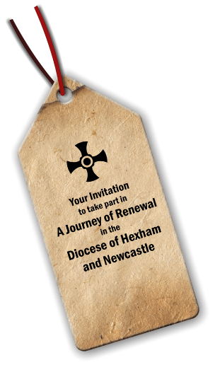This is an invitation for us all to use our imagination. If we start from the premise that the only boundary in our diocese that cannot be moved is our Diocesan Boundary – the North Sea, the Pennines and the two rivers, the Tweed and the Tees – how can we arrange ourselves in future with fewer priests and fewer people? How can we ensure that communities are viable and can flourish without presuming that every church building has to be used for the celebration of Mass? It does mean that Mass will be celebrated less often as the numbers of priests and people decline, but it might mean that some communities could maintain their local church building without it being used for the celebration of Mass.

Bishop Séamus quotes Pope Francis in his foreword. The Pope is inviting us to be flexible, open and missionary: *‘The parish is not an outdated institution precisely because it possesses great flexibility; it can assume quite different* ***contours*** *depending on the openness and missionary creativity of the pastor and the community.’*

This will not be easy. We have grown deeply attached to our own ‘parish’ over generations. We have become used to the convenience of Mass being at times that suit us. Until recently we had at least one priest living in and serving *every* community.

At the present moment we have 101 priests serving 150 parishes and 177 churches. We expect that in 2030, only fourteen years from now, there will be less than half that number. The graphs presented here remind us how the numbers of both priests and people have changed over time. It is interesting to note that the ratio of people to priests has remained quite constant over the past 35 years.

As Pope Francis says, the ‘contours’ of our parishes in future will be very different. We need to be flexible, missionary and courageous in our discussing and deciding. There is a danger that we could become rather inward looking over the next few months, defending our own parishes. But Pope Francis calls us to be ‘missionary’; to always look outwards, exploring how to build a world where everyone is respected, the fragile are welcomed, the needy are cared for, God is worshipped and we truly become the Body of Christ in our world today.

We will all be invited later in the year to discuss and name the local communities with which we could join to become a ‘Partnership’. By 27th November, we will need your ideas and suggestions so that we can begin to prepare a Partnership Plan for Bishop Séamus and the Diocesan Board to explore in the middle of January next year.

This will be the first attempt at producing what will be a ‘Flexible Plan’ for the whole of our diocese that brings together a number of existing parishes into ‘Partnerships’. The ‘partnership areas’ have not been decided and this is a very

important part of your exploration over the coming months.

In time, these partnerships will become more clearly defined and self-sufficient. It may well be that they will become parishes in their own right. This could happen soon in some areas while it may take longer in others. That is why the Partnership Plan will be flexible. The way it works out will depend, to some extent, on local circumstances; communities realising that they will not be viable or able to thrive without joining another; priests retiring or going to heaven; some communities taking longer to appreciate the need to engage more fully with another, and so on. It certainly does offer us the opportunity to wonder again what our local church is for and how we come together to witness to the Lord in this time and place.

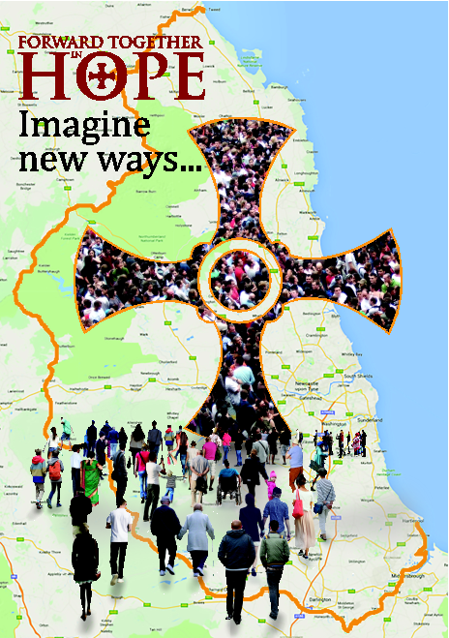At the same time, we will all be exploring what areas of parish life can be shared with lay people taking up leadership roles across the partnership area. In the document *What Our Clergy are Saying*,you will read that some are very clear that *‘we need to educate good lay people, encourage them, listen to them and their views and priorities’* and that *‘we need to step back and let lay people get on with it’.*

The really demanding part of *Forward Together in Hope*is the invitation to explore what it means to be a disciple of Jesus – that is what it is really all about. In the turbulence of exploring how we cope in practice with fewer priests and people it will be so important to keep this in focus. We will be shaken out of our comfort zones and this next phase will affect every parish in the diocese – even those who might feel ‘*We’re* safe, *we* won’t have to change’.

Some people are concerned about the expectation that more work in the Church will have to be done by lay people at a time when their numbers are decreasing. Rather than see it as ‘more work’, as if the work of the Lord was a big burden, perhaps we need to learn that responsibility can be shared between priests and people and that we can support one another in it. Some priests will have to let go of some of the things they’ve always done – administration, tasks around buildings, holding onto finance and so on – and some will find this very hard. At the same time, highly competent and trained lay people can manage all of this in less time and with less stress. Rather than see shared responsibility as a burden or a threat, perhaps we can learn to see it as service to the community we call the Church, so that the Church can witness to the Lord in our world.

**3.3 Imagine New Ways**

A leaflet, *Imagine new ways*…has been producedfor every parishioner in the diocese. Bishop Séamus is deeply aware that decisions will affect all parts of the diocese and so it is only right that every effort is made to engage and inform everyone.

The leaflet provides a brief summary of everything that is happening. It also suggests that we all take a moment, at noon every day, to bring the diocese to mind and pray for one another over the summer. Our prayer during these weeks might help us to be more open minded in our reflections later in the year.

Every parishioner is invited to complete and return the ‘tear off’ page attached to the leaflet and give it to either their parish priest or the *Forward Together in Hope* representative in their parish. This encourages everyone to give some thought to how they might work more closely with other communities, and how lay people could become more involved in sharing responsibility in the parish and partnership. Your comments may well be very useful later in the year when everyone will be asked to look carefully at both Partnership and Leadership.

It may be that some communities will be able to meet early in the summer to look at their *Observations* document and begin to think ahead about how to arrange meetings, initially in the parish, and then with other parishes in the area later in the year. It is certain that from September onwards, every parish will be looking at their *Observations* alongside *A Profile of your Parish in Numbers.*

Following these initial meetings each parish will join others in the area to look at the document *From Parish to Partnership.*By early September parishes will receive a template to help them work through their proposals and develop a Partnership Plan. This will need to be completed by 27th November and returned to the *Forward Together in Hope* team. It is from these ideas that the initial dioceasan-wide plan will be prepared and offered to Bishop Séamus and the Board in January.

It may be that each parish will need a couple of ‘Open Meetings’ to look at the *Observations*and *A Profile of Your Parish in Numbers*documents, and then a further couple of meetings with other parishes ‘in the area’ to explore the implications of *From Parish to Partnership*and the completion of the template we will provide. We will also prepare prayer and liturgy resources as a focus for the various meetings.

**3.4 What Can We Do Now?**

* Continue to pray for the guidance of the Holy Spirit throughout our diocese.
* Parish Priests and Parish Representatives make the various documents widely available to as many people as possible.
* Parish Representatives and the Parish Priest to ensure that the *Imagine new ways…* leaflet is distributed to every parishioner as soon as possible.
* Parish Councils (or equivalent) to be made aware of all the documents in preparation for parish meetings.
* If possible, arrange for an initial planning meeting in the parish to look at *Observations,* *A Profile of Your Parish in Numbers,* and *From Parish to Partnership.*
* Begin to arrange parish meetings to take place by late Summer.
* Begin to make the arrangements for meetings with neighbours.

During the Autumn, members of the *Forward Together in Hope* team will visit each area (at Deanery or Vicariate level). We will meet with all priests, parish representatives, representatives from schools and any parishioners who wish to attend, to explore how partnerships might look and how we can explore lay leadership formation.



Bishop Séamus noted in his Pastoral Letter

for the 14th Sunday of the Year that,

‘*Jesus appointed seventy two others*

*and sent them out in pairs*

*to all the towns and places he was to visit’*.

We are all disciples of Jesus

and we are all sent to witness to him

in all the towns and villages we inhabit.

The next phase of our journey invites us to be

flexible, courageous, missionary

and open to the Holy Spirit.

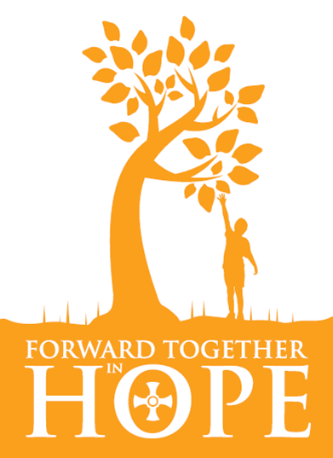

**Acknowledgements**

We see *Forward Together in Hope* as a shared responsibility of everyone in our diocese and owe a huge debt of gratitude to the many people who have contributed to this work over recent months.

In particular, I would like to thank:

* The Diocese of Belleville which sparked off some of our original ideas, and their Vicar General Mgr Jack McEvilly for his visit during the year.
* Xavier Javier for his vital assistance in producing two DVDs.
* The pupils of English Martyrs School and Sixth Form College, Hartlepool.
* Bill Campbell for his production of our ‘Questions and Answers’ DVD.
* Those who appeared in the ‘Questions and Answers’ DVD, namely: Phil Baxter, Rev. Jeff Dodds, Julia Henzell, Sister Innocentia (Missionaries of Charity), David Khachikian, Rev. Deacon Jeff Parkes, Veronica Shearer and John Stopher.
* Kathryn Turner and Karen Brown who have worked on prayer and liturgy resources.
* Professor Karen Kilby and Dr Mathew Guest, Centre for Catholic Studies, University of Durham, whose professional advice and assistance regarding developing and reviewing the various surveys and questionnaires has been invaluable.
* Dr Jocelyn Bryan and Rev. Dr David Wilkinson for assistance with Lay Leadership and Clergy Survey discussions.
* Members of the Development Group who oversee the work of *Forward Together in Hope,* namely Kathleen Smith, Kathryn Turner, Bill Dryden and Rev. Martin Stempczyk.
* The extremely dedicated and committed volunteers from across the diocese who have been involved in coding, reviewing and moderating all surveys and questionnaires:

Andrew Barron, Phil Baxter, Vicki Bramley, Karen Brown, David Brickland, Michael Broadbent, Peter Brookes, Jeremy Cain, Amy Cameron, Phil Cunningham, Jim Darlington, Pat Dick, Dot Fahey, Mgr Andrew Faley, Julia Firbank, Brid Fitzpatrick, Deirdre Grzebalski, Gerry Green, Mavis Harris, Rev. Deacon John Hawthorne, Angela Helm, Steve Helm, Julia Herron, Helen Hunt, Kirstie Hutchinson, Fran Hyde, John Kain, Peter Kelly, Pat Kennedy, Anne Lawlor, Terri Leach, Jeff Ledger, Andy Lee, Rev. Simon Lerche, Cathy Marshall, Jim McLaughlin, Rev. Deacon Richard McLaughlin, Lillian Molloy, Mary Moody, Rev. Deacon Jurgen Muller, Andrea Murray, Katherine Nugent, Paul Nugent, Frank Pollard, Anne Porter, Mike Quincey, Helen Ramsey, Veronica Shearer, Ged Stewart, Barbara Sweeney, Michael Thompson, Kathryn Turner, Claire Walton, Barbara Wareing, Rev. Deacon Rob Wareing.

* Joe Ronan for an extraordinary amount of data input, analysis and reporting.
* John Sampson Babatunde for data inputting.
* The Episcopal Vicars and Deans for their ongoing support and ever-increasing involvement - and Bishop Séamus for his supportive leadership.

Finally, very many thanks to my many colleagues in various Curial Departments, some of whom have spent many hours of their own time putting data into a useable form and checking financial information. While we have done our best to ensure that all information included in this resource pack is accurate, I apologise in advance and take responsibility for any omissions or inaccuracies you might discover.

**Jim O’Keefe**

Diocesan Development Director

The *Forward Together in Hope* team: Jim O’Keefe, Tony Sacco and Nancy Gash can be contacted on:

Telephone: (0191) 243 3304 E-mail: hope@diocesehn.org.uk

Diocese of Hexham and Newcastle, Department for Development and Renewal

Tel: (0191) 243 3304 E-mail: hope@diocesehn.org.uk Web: www.hope.rcdhn.org.uk

©Diocese of Hexham and Newcastle – June 2016

Also available in other formats

